Invitation Letter | Dear Prof. Dong LUO,  On behalf of the International Meeting on Lithium Batteries (IMLB) organizing committee and the IMLB scientific advisory committee, we would like to cordially invite you to attend the 22nd edition of the International Meeting on Lithium Batteries to be held in Hong Kong from June 14 to 21, 2024.  This conference provides a great opportunity to exchange ideas and discuss research topics in cutting edge areas of energy storage in general and electric vehicles in particular.  IMLB 2024 Conference will bring together high-level policy makers from China, North America, Europe, Japan and Korea, in addition to most car manufactures, battery industry makers and world renowned scientists from academia share their recent research findings.  Please visit https://www.imlb.org/ to learn more about the conference. If you require further information, please let us know.  We look forward to your positive response.  Best Regards,  Prof. Guohua Chen  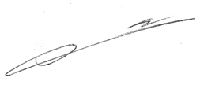  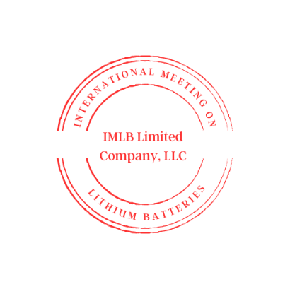  IMLB 2024 Chairman  Dean, School of Energy and Environment  City University of Hong Kong  (852)34429020  Email: guohchen@cityu.edu.hk
President
Chen, Guohua - CityU, Hong Kong

Vice Presidents
Amine, Khalil - ANL, USA
General Secretary
LIU, Qi – CityU, Hong Kong

